**Assignment 4_2**

1. Write a program to create bar plots for all the categorical columns in mtcars.

**Answer:**

**par(mfrow=c(2,3))**

**barplot(mtcars$cyl, main="By CYL")**

**barplot(mtcars$vs,main="By VS")**

**barplot(mtcars$am, main="By AM")**

**barplot(mtcars$gear, main="By GEAR")**

**barplot(mtcars$carb, main="By CARB")**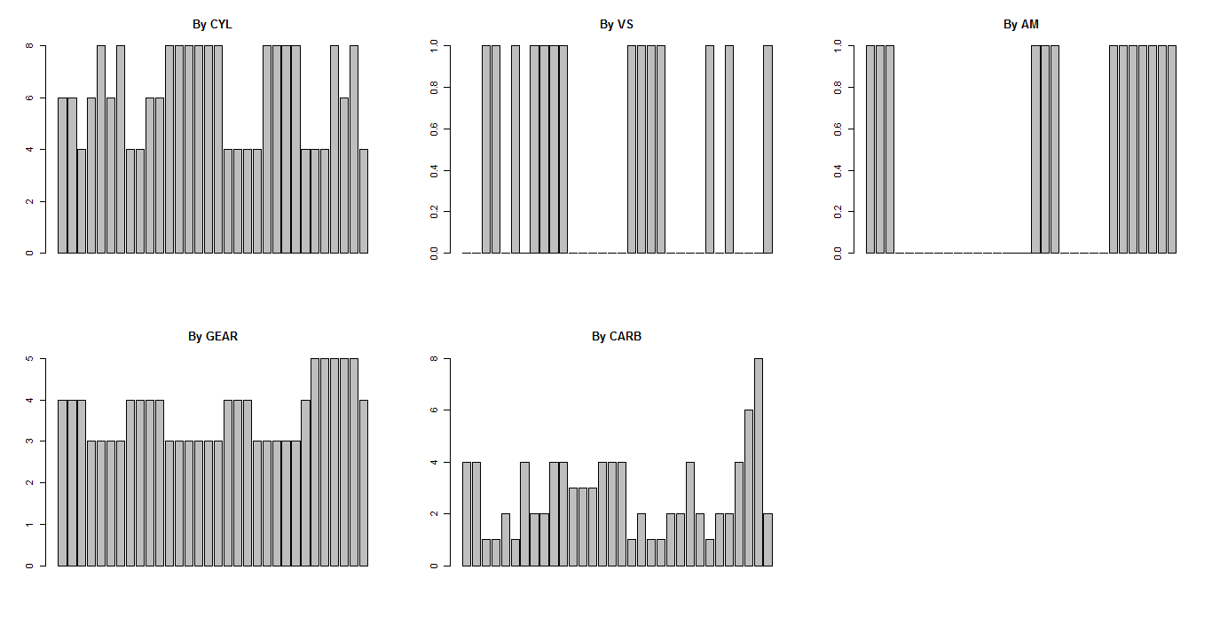

2. Create a scatter plot matrix by gear types in mtcars dataset.

**Answer:**

3. Write a program to create a plot density by class variable.

**Answer:**